 | 8.3.3 Editors - Image Editor - Sidebar - View Tab
Table of content
Introduction 2
Display Panel 2
Aspect Ratio X , Y 2
Repeat 2
2D Cursor Panel 2
Annotations Panel 2
Annotations prop 3
Drop down box 3
Edit Box 3
Fake User 3
Add Annotation 3
Delete Annotation 3
List of Annotation Strokes 3
Opacity 3
Thickness 3
Frame Locked/Unlocked 3
Delete active frame 4

Introduction

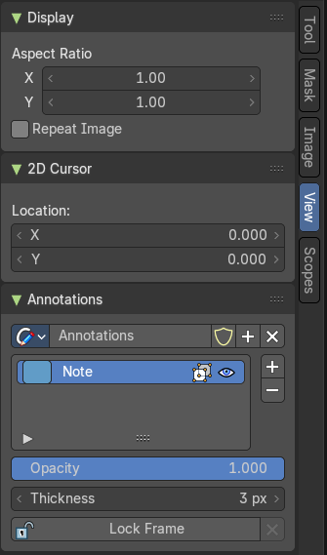
The View tab contains some view related settings. And it contains the annotation panel.

Display Panel
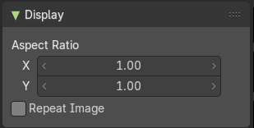

Aspect Ratio X , Y
Set the aspect ratio of the image.

Repeat
With this ticked the image is repeated in the UV Image canvas.

2D Cursor Panel
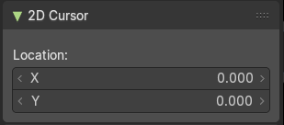
See and set the 2D cursor location.

This panel is just visible in Mask mode.

Annotations Panel
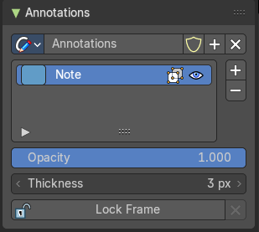
Manage the Annotation layers and materials.
When you don't have drawn an annotation yet then the panel just contains a New button.


Annotations prop

Add, remove and rename new annotations.

Drop down box

A list of the available annotation layers.

Edit Box
The name of the current annotation. You can rename the annotation to your needs here.

Fake User
Assign a fake user to this annotation. Fake users is an odd concept to keep data in the scene even if it has no user somewhere. The fake user is then a dummy user so that the object is not deleted when saving the scene.

Add Annotation
Add a new annotation.

Delete Annotation
Delete the annotation.

List of Annotation Strokes

Here you see your Annotation layers for the current Annotation. Every layer can have an own color.
At the right side you find buttons to sort them and to add and remove new Annotation layers.
You can change the color by clicking at the color field. A color dialog will pop up. You can rename annotation layers by double clicking at it.
The eye icon allows you to make it invisible And it has a search field.

Opacity
The annotation layer opacity.

Thickness
The thickness of the annotation stroke.

Frame Locked/Unlocked
Lock frame displayed by current layer. This toggles whether the active layer is the only one that can be edited.

Delete active frame
Delete the active frame from the active annotation layer.

